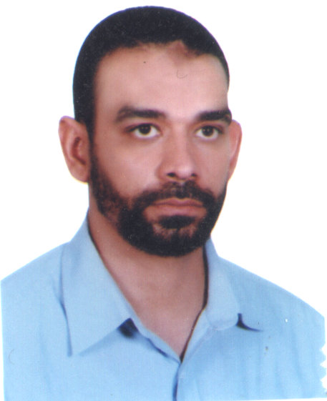
Curriculum VitaeDr. Hany El-Gamal
Physics Department

Faculty of Science
Assiut University
E-mail: hanyelgamal2000@yahoo.com
Tel: +20-100-7851312
Fax: +2(88) 2342708

Personal
- Born 31 March 1974 in El-Menoufia, Egypt
- Married since 2000, four children (2001/03/05/2011)

Research
- Since 2005: Lecturer, Physics Department, Faculty of Science, Assiut University, Egypt. Research areas: Aquatic systems, groundwater, tracer, isotope methods and radiation physics.
- 2002 - 2005: Research and Teaching Assistant, Institute of Environmental Physics, University of Heidelberg (IUP Heidelberg, Germany). Ph.D. thesis about "Environmental tracers in groundwater as tools to study hydrological questions in arid regions", supervised by Prof. Dr. Werner Aeschbach-Hertig (IUP Heidelberg, Germany)

Education
- 2000-2002: (M.Sc.) in environmental physics, IUP Bremen, Germany. M.Sc. thesis about "Application of T-³He method in groundwater study".
- 1992-1996: (B.Sc) in physics, Faculty of since, El Menoufia University, Egypt.
Publications
- El-Gamal, H., A.I.A. Mageed, 2014. Natural radioactivity in water samples from Assiut city,Egypt. Int. J. Pure Appl. Sci. Technol., 22(1) : 44-52.
- El-Gamal, H., M.E.A. Farid,2014. Trace elements and radioactivity levels in water near Assiut thermal power plant, Egypt. Int.J.Sciences., 3(9):12-15.
- Sueltenfuss, J., H.El-Gamal, 2014. Infiltration of Lake Water into the Groundwater System Investigated by Tritium/Helium-3 Method: An Example from Wannsee and Lieper Bucht Area, Berlin, Germany. Int.J.Sciences., 3(9):16-25.
- El-Gamal, H., M.E.A. Farid, A.I.A. Mageed, M. Bady and M. Hasabelnaby et al., 2013. Monstrous hazards produced by high radioactivity levels around assiut thermal power plant. Am. J. Environ. Sci., 9: 388-397.
- El-Gamal, H., M.E.A. Farid, A.I.A. Mageed, M. Hasab and H.M. Hassanien, 2013. Considerable hazards produced by heavy fuel oil in operating thermal power plant in Assiut, Egypt. Environ. Sci. Pollut. Res., 20: 6331-6336. DOI: 10.1007/s11356-013- 1670-5
- El-Gamal, H., M.E.A. Farid, A.I.A. Mageed, M. Hasabelnaby and H.M. Hassanien, 2013. Assessment of natural radioactivity levels in soil samples from some areas in Assiut, Egypt. Environ. Sci. Pollut. Res. DOI 10.1007/s11356-013-1844-1
- H. El-Gamal, "Tritium/Helium-3 Dating of River Infiltration:An Example from the Oderbruch Area, Berlin, Germany," Journal of Water Resource and Protection, Vol. 5 No. 1, 2013, pp. 46-53. doi: 10.4236/jwarp.2013.51006.
- Aeschbach-Hertig, W., H. El-Gamal, M. Wieser, and L. Palcsu, 2008. Modeling excess air and degassing in groundwater by equilibrium partitioning with a gas phase. Water Resour. Res. 44, W08449, doi:10.1029/2007WR006454.
- Aeschbach-Hertig, W., H. El-Gamal, K. Dahab, R. Friedrich, R. Kipfer, I. Hajdas, 2007. Identifying and dating the origin of groundwater resources in reclamation areas of Egypt. In: Advances in Isotope Hydrology and its Role in Sustainable Water Resources Management (HIS-2007), Proceedings of a Symposium, Vienna, 21-25 May 2007. IAEA, Vienna, STI/PUB/1310, Vol. 2: 395-403.
- Aeschbach-Hertig, W., H. El-Gamal, K. Dahab, R. Kipfer, G. Bonani, 2006. Environmental tracer study of groundwater recharge near the Nile Delta, Egypt. DPG-Fruehjahrstagung Heidelberg, E-Verhandl. DPG,UP1.6 DPG-Frühjahrstagung Heidelberg.
- Aeschbach-Hertig, W., H. El-Gamal, K. Dahab, R. Kipfer, I. Hajdas, G. Bonani, 2006. Using environmental tracers to assess groundwater resources in reclamation areas of Egypt. EGU General Assembly, Vienna. Geophys. Res. Abstr., 8, EGU06-A-05515.EGU General Assembly 2006, Vienna.
- El-Gamal, H., K. Dahab, W. Aeschbach-Hertig. 2004. A multi-tracer study of groundwater in reclamation areas south-west of the Nile Delta, Egypt. International workshop on the application of isotope Techniques in Hydrological and Environmental studies. UNESCO, Paris, France. p.99 . International Workshop on the Application of Isotope Techniques in Hydrological and Environmental Studies.

